Name : Mohamed Ali | Student ID : n01440760
Date: March 31, 2026 | Professor Signature:

Lab 7 – MIPS Architecture Design – Instruction Set

The purpose of this lab is to study MIPS architecture and simulate MIPS computer structure in C program. MIPS (Microprocessor without Interlocked Pipeline Stages) architecture is a widely used 32-bit RISC CPU architecture originally developed by MIPS Technologies, Inc. in the 1980s. MIPS CPUs support only three different instruction types: I type, R type and J type, which makes this instruction set relatively easier to implement and simulate. There are 32 general and 32 floating point registers in MIPS architecture. In this lab, you will need to finish the function required by the simulator to simulate the MIPS program loading and compiling process.

Procedures
- Download the lab7 named lab7.zip package from the blackboard.
- Now create a project under C development environment, such as Code:Blocks, Netbeans or Eclipse. Please try to avoid using Munro as the limited debug interface.
- Hint: Starting from this week, the code will be more and more complicated. As a result, you should consider having a consistent development environment and backup your code more frequently because these labs will need the code you developed in lab 8 and 9.
- The lab package includes the following files:
  - parser.c - This file has the functions to load the assembly code from the file system and compile it into data structures.
  - Lab7.c - This file includes the major functions you need to finish in this lab, you need to read the data structure set up by parser.c to hold both CODE and DATA section of the assembly code in MIPS.asm and convert them into machine code based on MIPS instruction set. You only need to change this file in lab 7.
  - memory.c - This file includes the functions to set up the memory for MIPS CPU (needs your finished lab 6 memory.c code).
  - main.c - This is the main functions of the MIPS computer system structure. We will keep on adding new functions to this file in the next 2 labs.
  - header.h - The header files for the project.
  - parser.h - The header files for parser.c file.
  - MIPS.asm - The assembly code for the testing of the program running on the simulator.
- Build a C project named lab7 and include all the .c and .h files into the project, please notice that MIPS.asm file is used as the input file to the program, it is NOT part of the project to compile.
- This program needs to read the assembly code MIPS.asm from hard drive to execute, so please try to add the path to the MIPS assembly language code MIPS.asm as an argument to the run command. Please notice that different IDE would have different settings, you may need to refer to the help document to find this setting. The following screenshot is for Code:Blocks IDE only, you can reach to this screen by going to “Project-> Project Program’s Arguments…”.
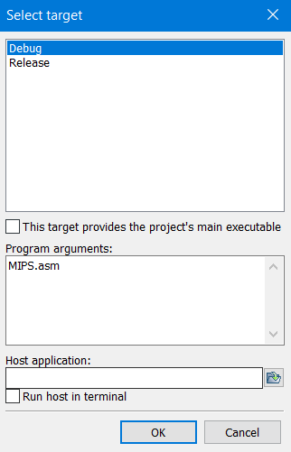
- Study the MIPS instruction set definition based on the course materials and lecture notes. Follow the examples your professor gives you during the class time, make sure you understand the 32-bit instruction set structure and how to translate the assembly code into its 32-bit machine code.
- Now try to understand the code, read the comments in function loadCodeToMem and try to finish the following functions in lab7.c:
buildIInstruction,
buildJInstruction,
buildRInstruction,
setupDataMemory,
setupInstructionMemory.
- Notice: Before you finish function setupInstructionMemory, you need to answer all the questions in the comment part to make sure you are following the right direction.
- You need to use the memory dump function you wrote in lab 6 to display the first 256 bytes in the code and the data sections in the memory. The offset address of the code section is 0x0000 (defined as CODESECTION in the code), and the offset address of the code section is 0x2000 (defined as DATASECTION in the code).

Please follow the following submission requirements for this lab:
- This is an individual lab project.
- Must answer all the questions in the comments of each of the instructions.
- The lab report is due on the blackboard, please check the submission folder of the blackboard.
- You need to display the memory dump of both the instruction and data sections in the memory, starting from the offset address of 0x0000 (Code section) and 0x2000 (Data section), respectively. Submit these two screenshots and your source code lab7.c with your report. All screenshots must show the local computer time/date.
- Submit the link to your repo with your code.

